**Dataset Analysis and Visualization:**

The dataset is about customer satisfaction of a particular restaurant. It contains informations in various column which includes customerID, age, gender, frequency of their visit, average spend on food, preferred cuisine, visiting time, groupsize ,meal type whether it is a dine-in or takeaway, whether they have reserved their seats online, whether they order food online or not, their wait time, service rating , food rating, ambiance rating and their satisfaction level.

**1. How does average spend vary with age? Does a particular age group tend to**

**spend more?**

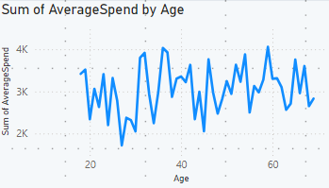

Here we can see that average spend of customer vary with ages. We can see 30-60 age group people spend a lot. For a better understanding I made age group of width 10 from the age between 10 and 70.

The above plot is showing that 50-59 age group tends to spend more in a restaurant.

**2. Find Gender-wise delivery orders for each meal type.**

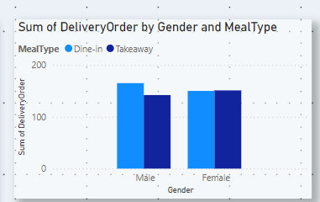

This above plot is showing how male and female customers prefer their mealtype. Whether they like to order online and get delivered in their place or to come and eat in the restaurant.

**3. Show the distribution of preferred cuisine and food rating. What meal types**

**are most popular among different income groups? Does the preferred meal**

**type impact spending?**

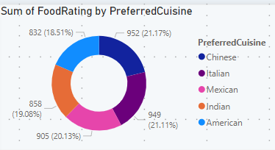

This is a donut chart which is showing food rating of the customers against their preferred cuisine.

This is showing that people having different income groups have different meal type preference.

Like people in 100000-119999 income group prefer takeaway than dine-in.

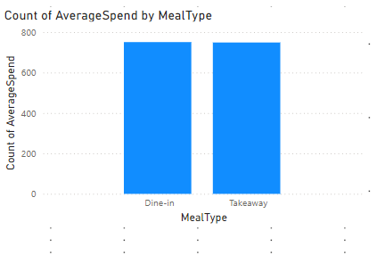

No, according to this chart the preferred mealtype doesn’t impact spending.

**4. Apply any 2 aggregate functions.**

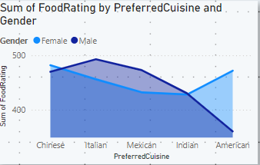

Here, sum of foodrating is showing against customers’ various preferred cuisines and their gender.

Sum is used as an aggregate function here.

**6. How does wait time affect customer satisfaction? Is there a noticeable**

**decline in satisfaction with increased wait times?**

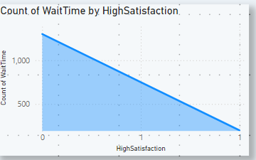

Yes , a decline is noticed when customer’s wait time is increasing. So, when the wait-time is less, customers seem to be more happy.

**7. Give extra 2 insights from your understanding.**

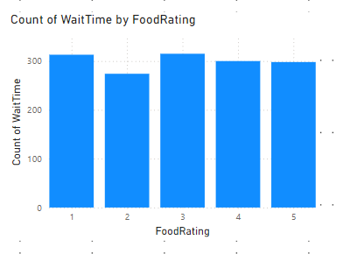

This column chart is showing waittime vs the rating given by the customer. When the wait time is increasing they tend to get 3 rating.

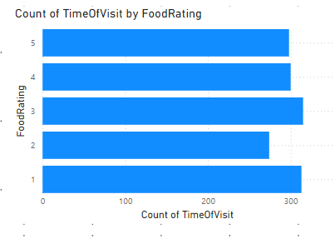

This bar chart is showing that the visiting time of the customers and foodrating given by them.

**The final dashboard is looking like this:**

